My current goals for this project is to:
- Set up a running Virtual Machine (VM)
- Install windows server 2022
- Give it a name/set it up.
I will be documenting all my encounters.

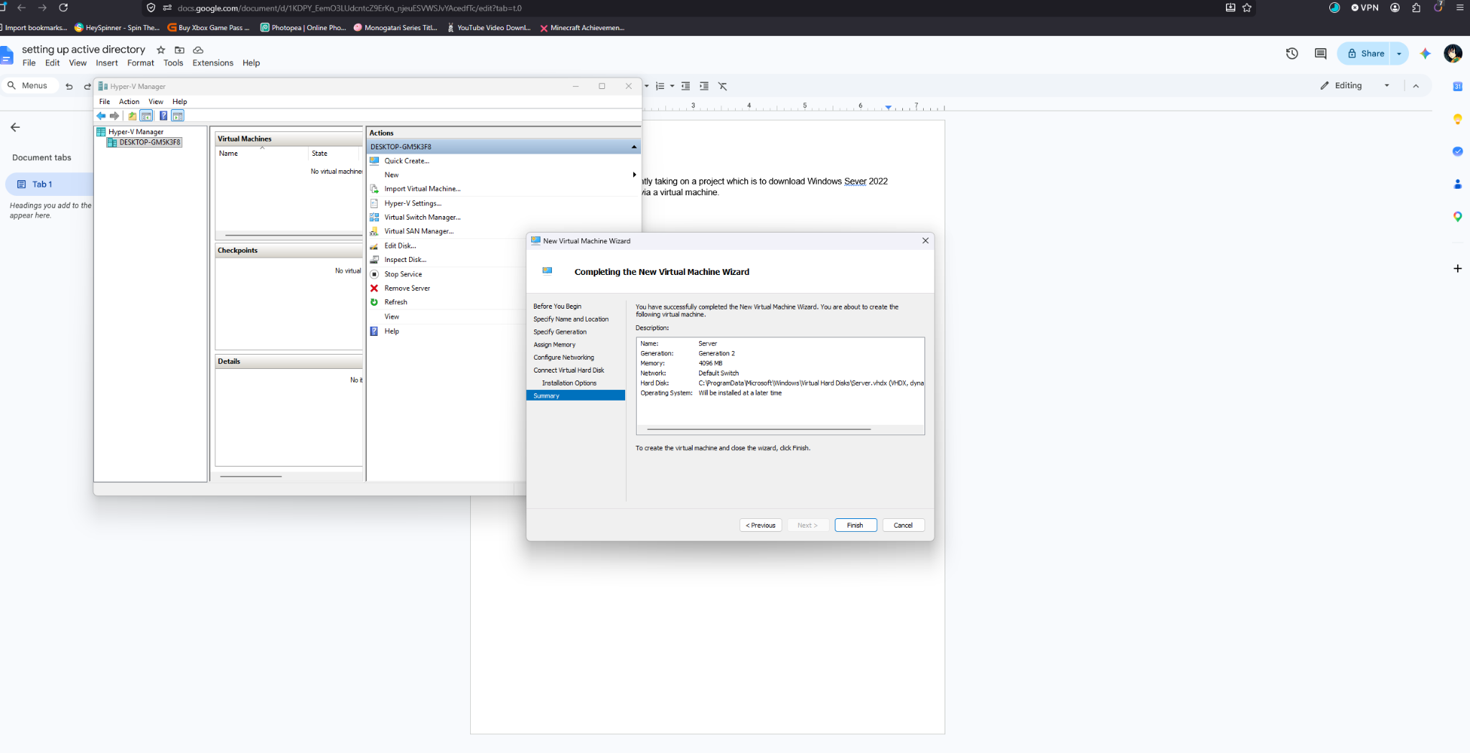
This is my setup on Hyper-V, currently the ISO is being downloaded. 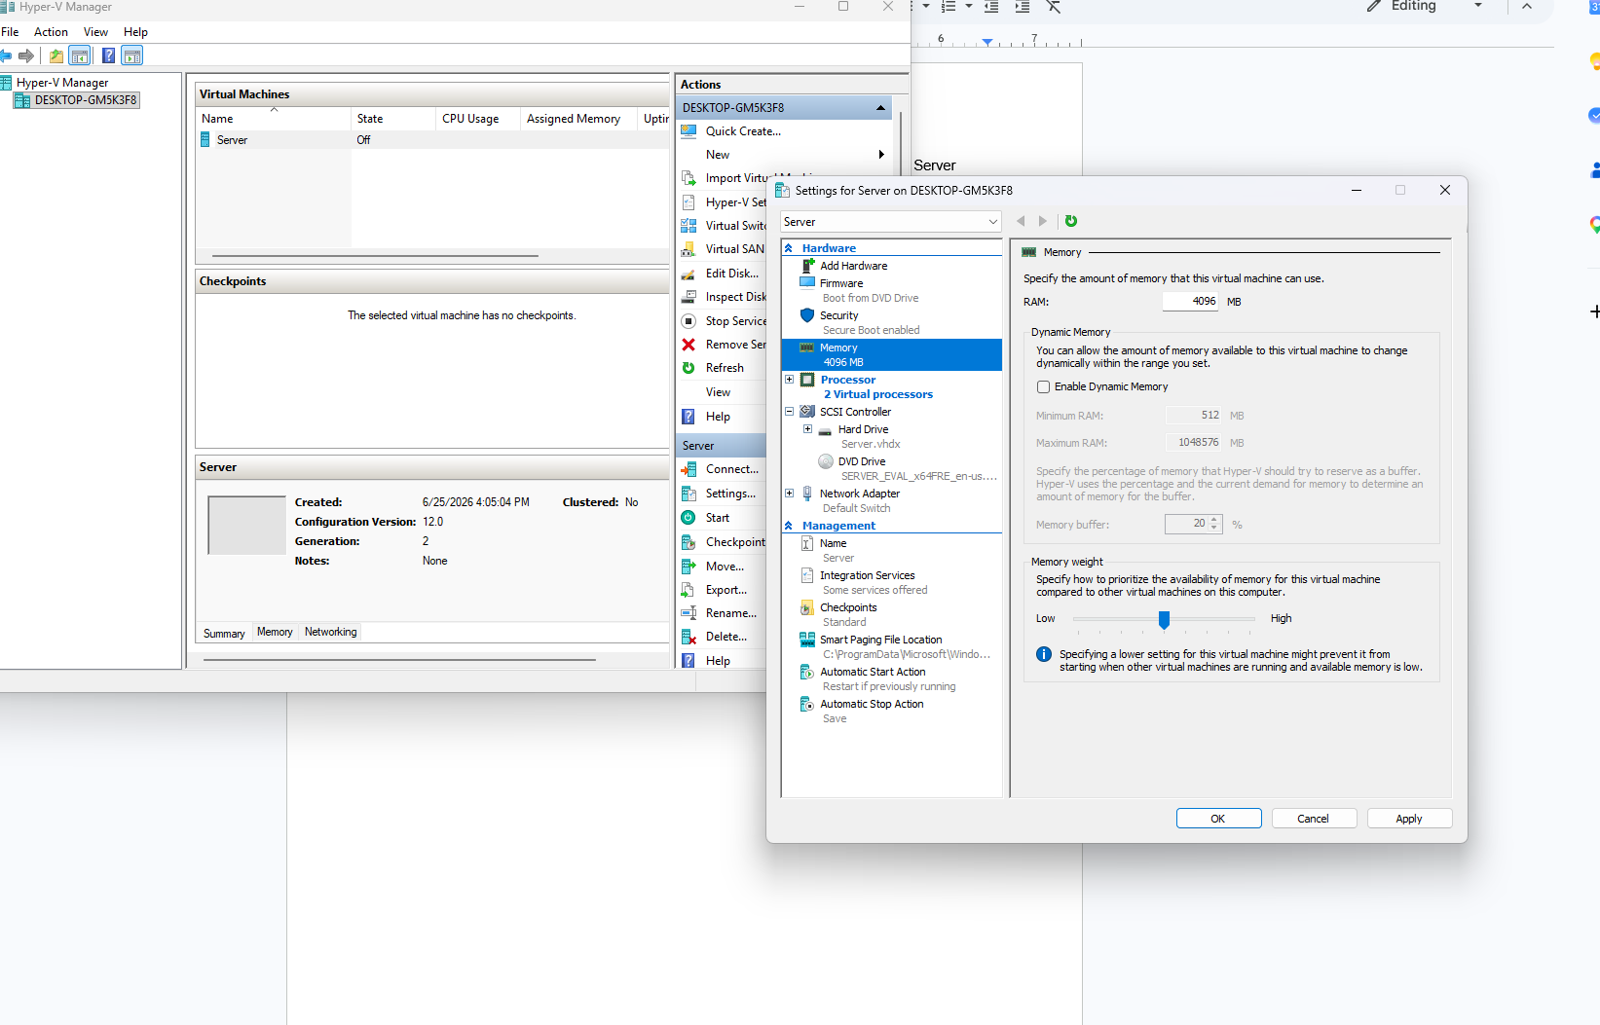
I chose two vCPU’s so it isn’t resource intensive, but now I’ll boot it up and set it up.
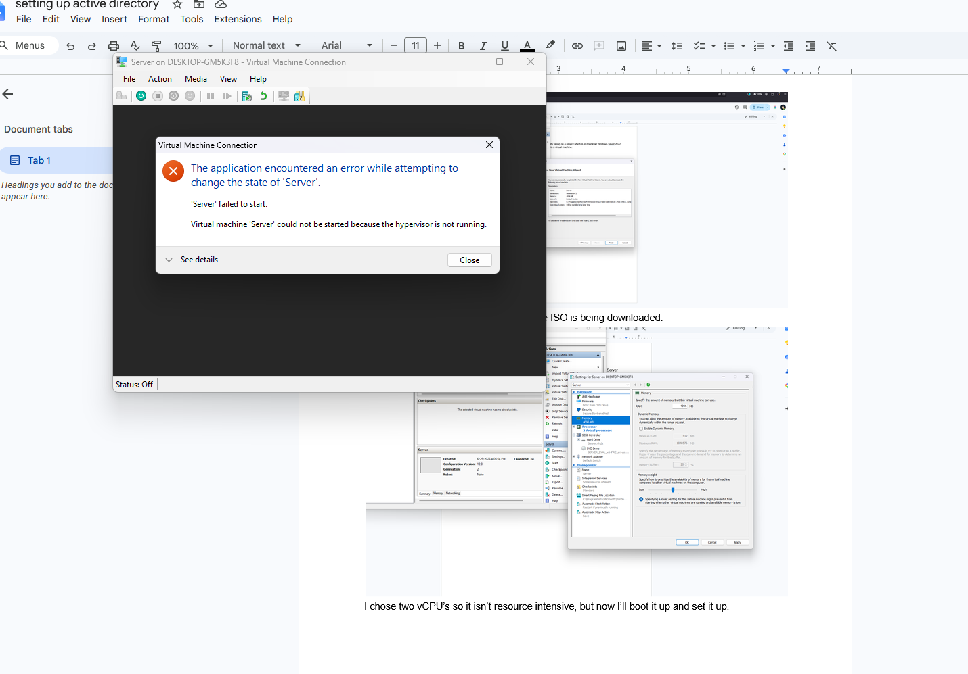
First boot failed, I researched what was causing the issue, and one key point I’m finding is it has to do with a setting in my bios. So I’ll restart my PC, enter bios mode and toggle the SVM (Secure Virtual Machine) setting.
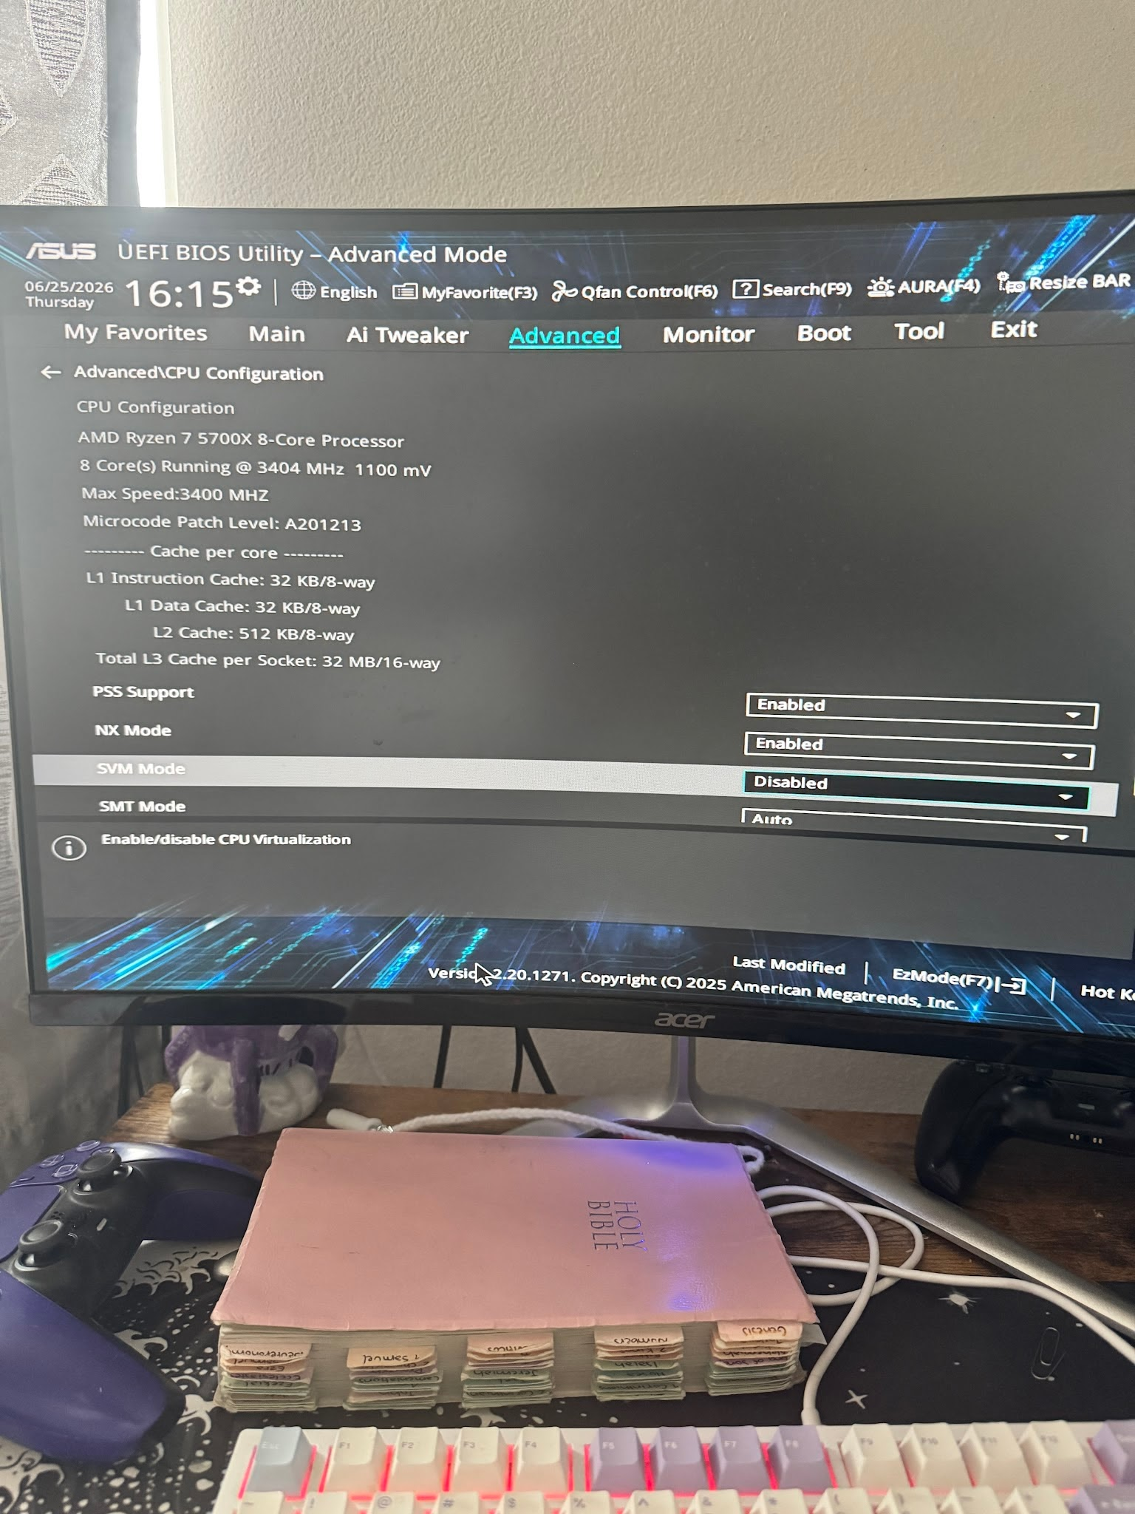
The SVM mode is toggled on, time to save and reboot my device.
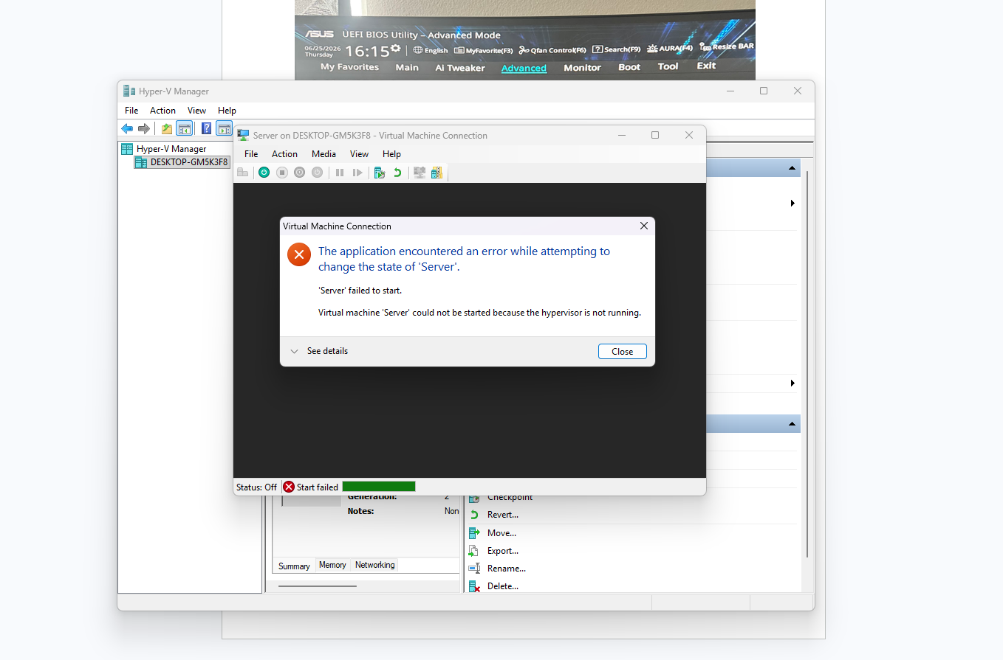
With my device rebooted, I attempted once again to see if my server would finally boot, just for the same error to happen.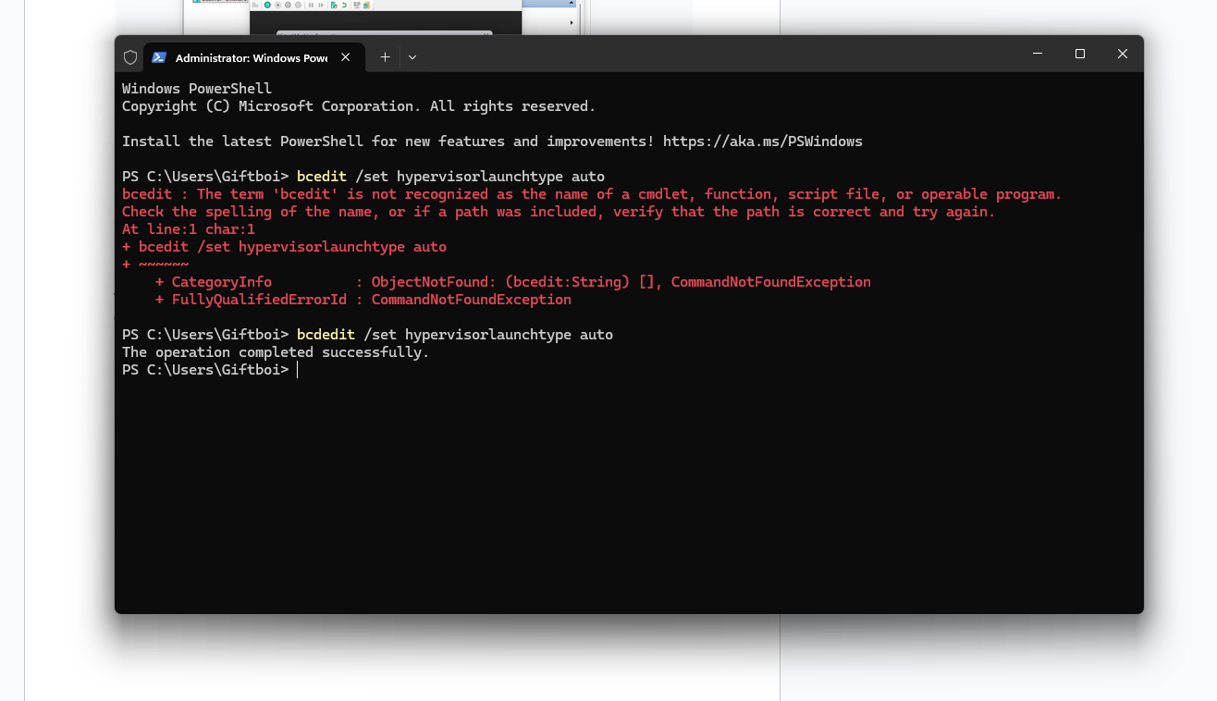
This time I managed to research the cause since I had never encountered this error before. I had read the error code to gain a better understanding and found a solution to change boot configuration data. I typed out “bcdedit /set hypervisorlaunchtype auto” in command prompt. I'll restart my pc and see if it works.
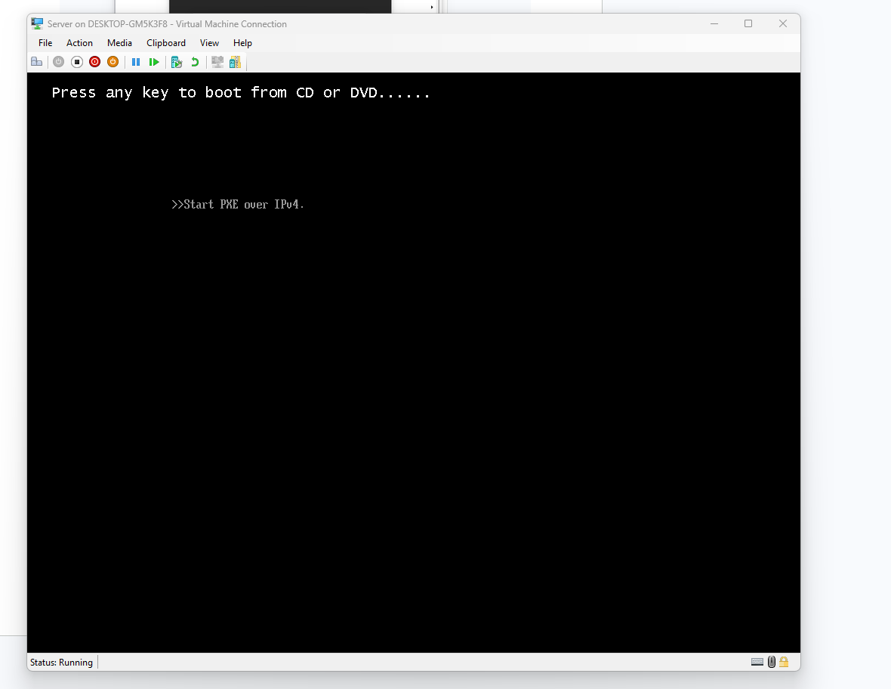
Good News, it boots up. Bad news I forgot to change the boot drive, I had attempted to change the boot drive order to see if it would work, but it didn’t.
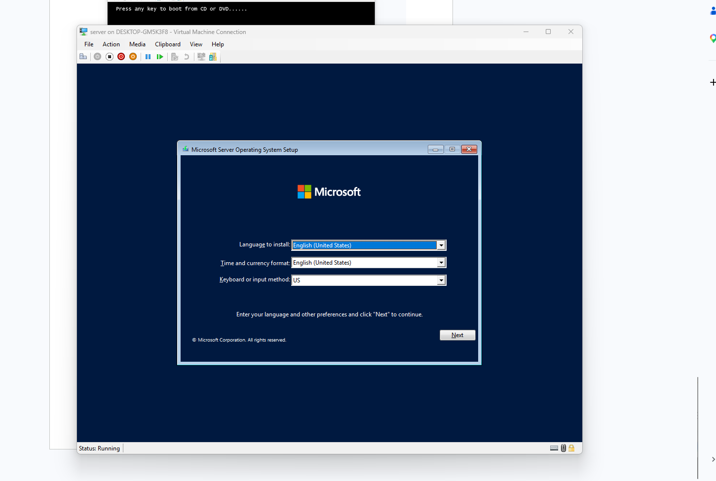
I got it boot up!!, turns out I had set up the virtual machine incorrectly which is why I kept on getting the boot error. I had used gen 2 when I should've used gen 1 when setting up the vm. My updated vm settings are shown below after this image.
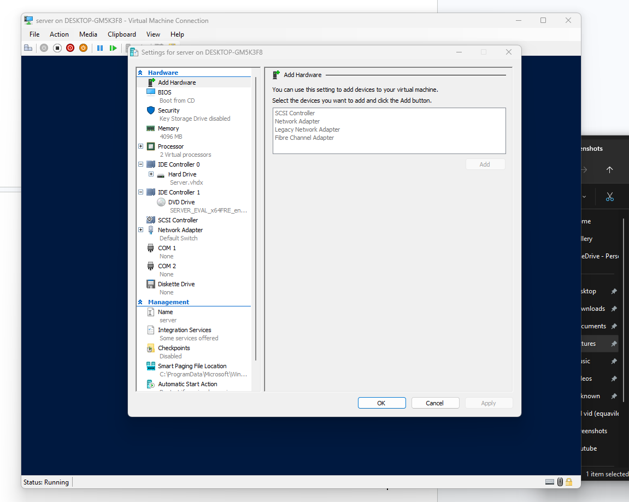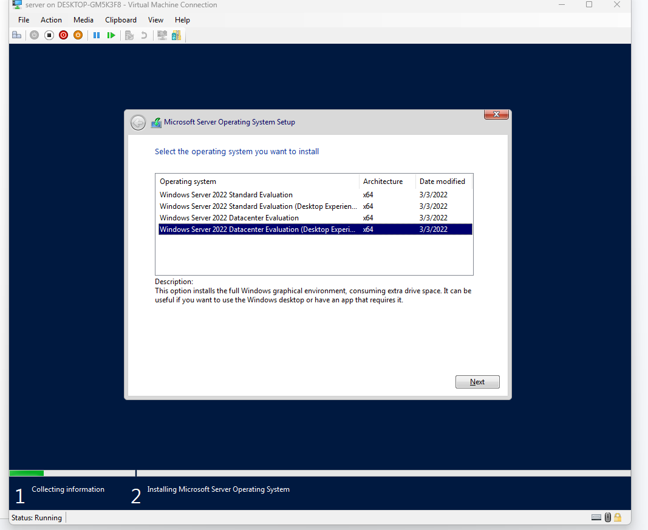
I chose the version I’m most accustomed to for installation. After waiting for it to finish up, I created my login and was greeted at the home page.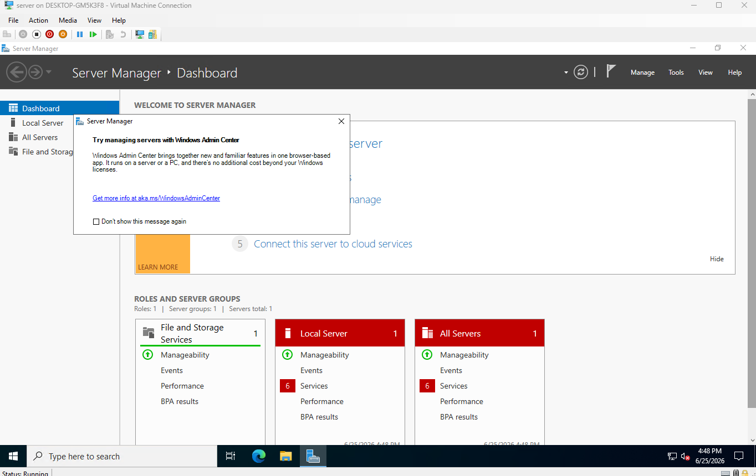

Setting up this server has brought up new challenges I’ve never faced before, but I remained calm, assessed the situation by reading the error code and tried the options given to me in said error. It’s a simple task but in more projects it’ll only get more difficult. I now see the value of a simple installation of something that can be seen as routine.That an issue can arise at any given time with no proper explanation for it.